New EASO Practical Guide on the best interests of the child in asylum procedures

* 20TH FEBRUARY 2019

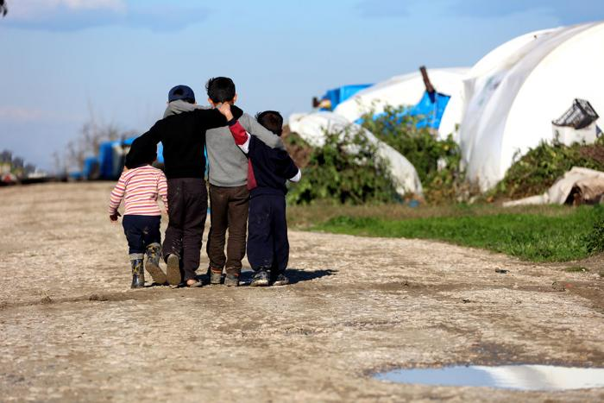

***EASO has published a new***[***Practical Guide on the best interests of the child in asylum procedures***](https://www.easo.europa.eu/sites/default/files/Practical-Guide-Best-Interests-Child-EN.pdf)***.***

**Why was this practical guide created?**

The aim of this practical guide is to help to identify and highlight the key milestones for the implementation of the best interests of the child. This is done in order to support EU+ states in applying the best interests principle and enhancing the guarantees within asylum procedures for children. EU+ states should establish child-friendly asylum processes that ensure the protection of the child throughout the procedure in line with EU and international law.

**How was this practical guide developed?**

This practical guide has been developed by EASO with the support of a group of experts from Belgium, Denmark, Finland, Ireland, Norway and Romania, as well as the European Commission, the European Union Agency for Fundamental Rights (FRA), the United Nations High Commissioner for Refugees (UNHCR) and the United Nations Children’s Fund (Unicef).

**What is in the practical guide?**

This new practical guide aims to provide guidance and support to the competent national authorities on the required guarantees and safeguards which will ensure that the child’s best interests are given primary consideration when making decisions affecting the child in the asylum procedures. It is divided into five sections including an overview of the terminology, the background and elements of the best interests of the child, the relevant guarantees, guidance on how to assess the best interests in practice and vulnerability and risk indicators.

At the end, the practical guide presents a comprehensive checklist designed to ensure that all key steps are completed by the responsible authorities and appropriately taken into account when assessing the child’s best interests. The guide is complemented with a set of annexes; a compilation of policy and guidance documents relevant to the topic and an overview of the legal framework including international, European and EU legal instruments.

**How to use this guide?**

The practical guide provides generic guidance and can be used as a benchmark or source of inspiration to update and/or improve specific standard operating procedures developed for children at national level.

The guide proposes a best interests of the child checklist which will support and ensure the ongoing information gathering and assessment process. It will enable the assessor to verify if the relevant information and safeguards have been provided with due consideration of data protection/security.

The practical guide can be used in conjunction with relevant EU, international and national legislation, respecting a child-rights approach.

The new Practical Guide is available in English language on the EASO website at <https://www.easo.europa.eu/practical-tools>. The document is currently being translated into other languages, which will be made available on the organisation’s website in the coming months.